Step by Step Dashboarding

We want to understand the WFH preference people which is percentage of time people are working from home.

1. Create a measure in measure table.

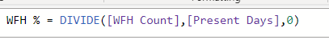

And add Card visual in percentage format

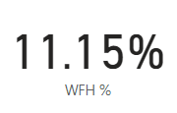

1. Create a sick leave count column in Data view level. Just like WFH count

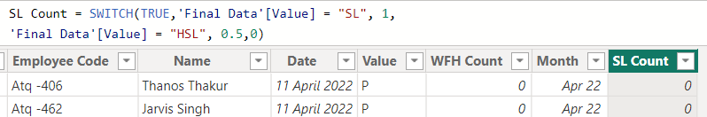

1. Create a sick leave count measure in measure table.



1. Next create SL % in measure table.



1. Who is going to under work from home. Which day people are doing work from home frequently.
2. Let’s add table visual. And drag the name. and the above presence %, WFH%,SL%

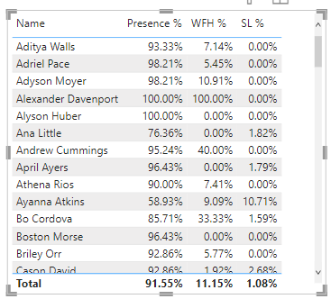

1. 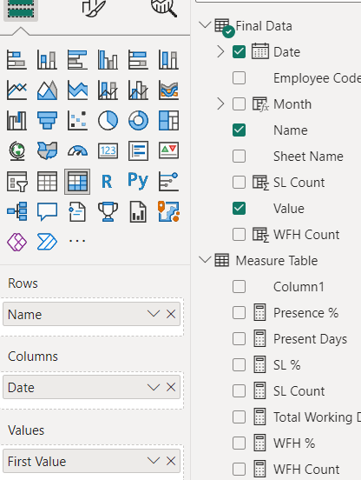Add the matrix visual to see the insights of particular employee about the presence behaviour.
2. 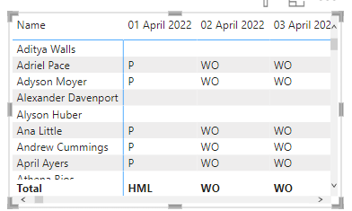add a trend line visual to check easily by date

In this visualization, added advanced date filter on or before jun2 17 because. We have that much data itself in our sheet right now

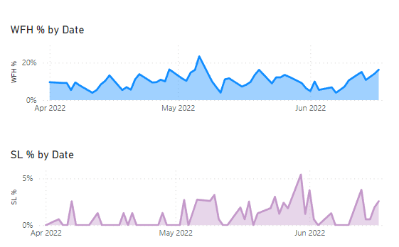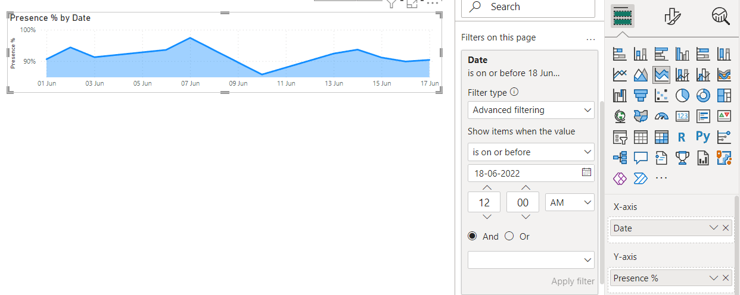  
similarly we need to do with WFH % and SL %.

9. Let visual which day of the week people are present most, took wfh most and absent most.

For that, we need the day of the week column

